**SUMYAK JAIN, 500068360, R171218106**

**EXPERIMENT-7**

**Deploy networked containers using the built-in Docker Orchestration**

1. **Create Swarm Mode cluster**

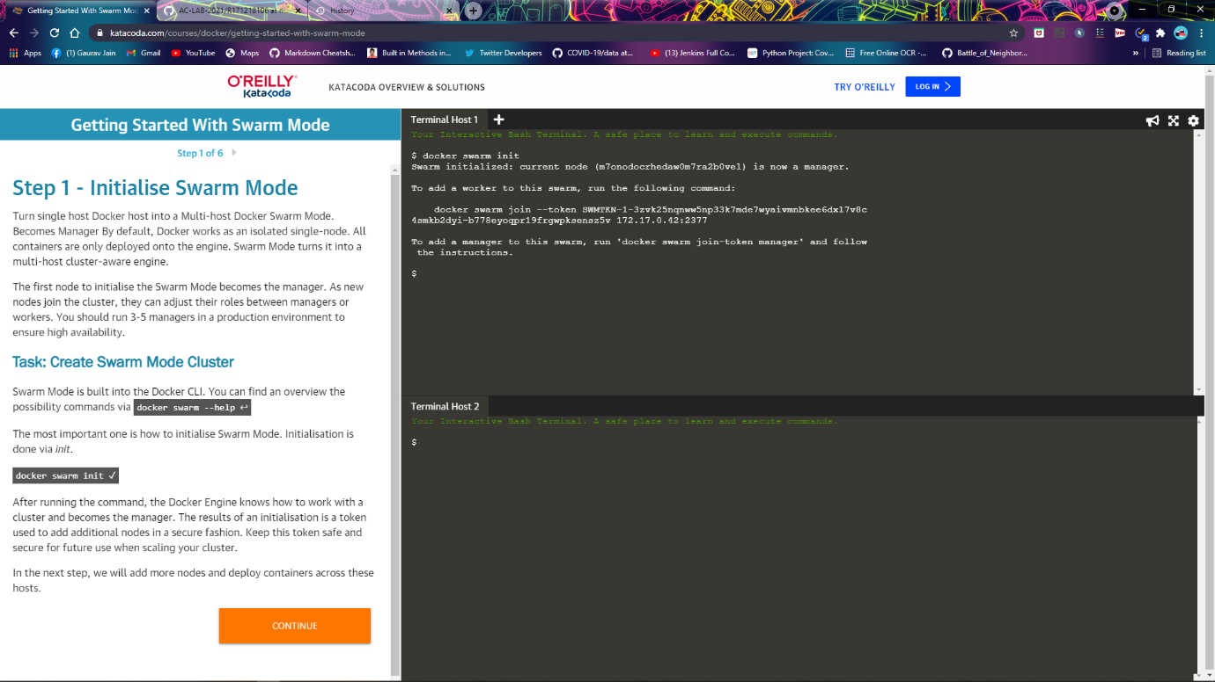

1. **Join cluster**

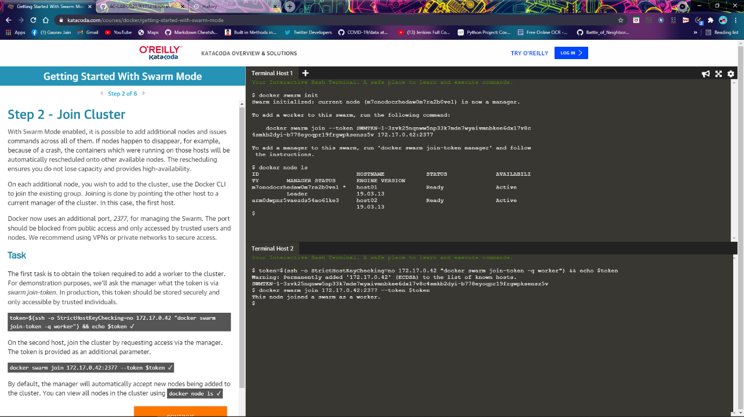

1. **Create overlay network**

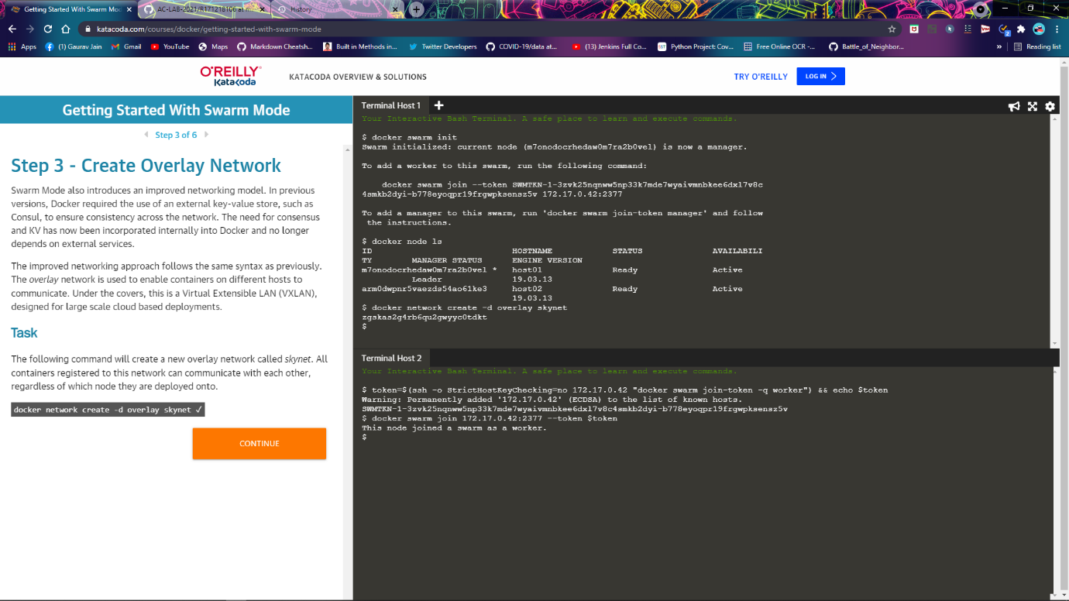

1. **Deploying the docker image katacoda/docker-http-server**

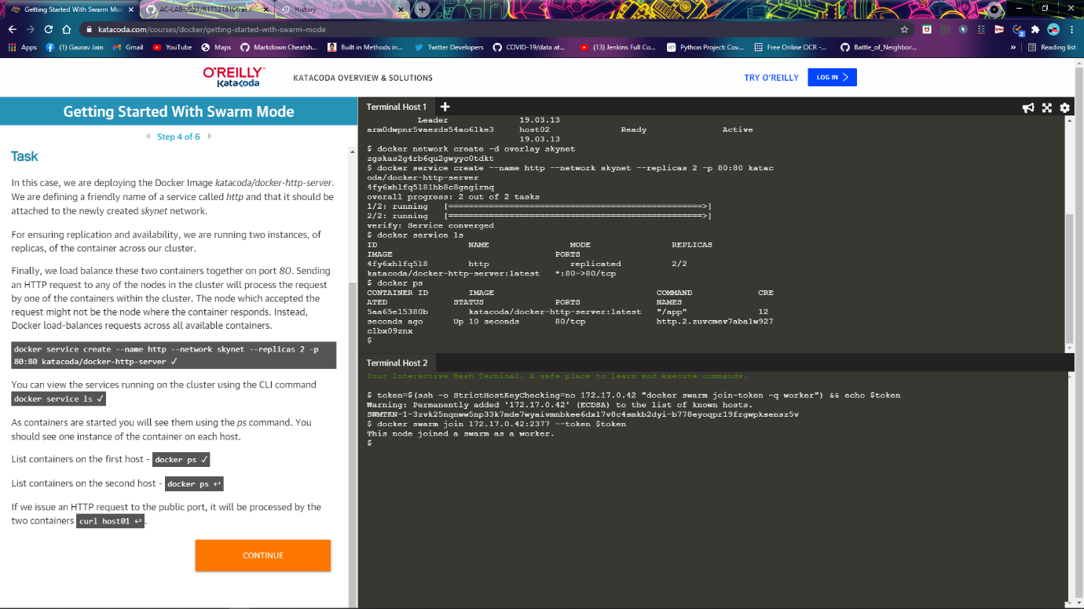

1. **Inspect state**

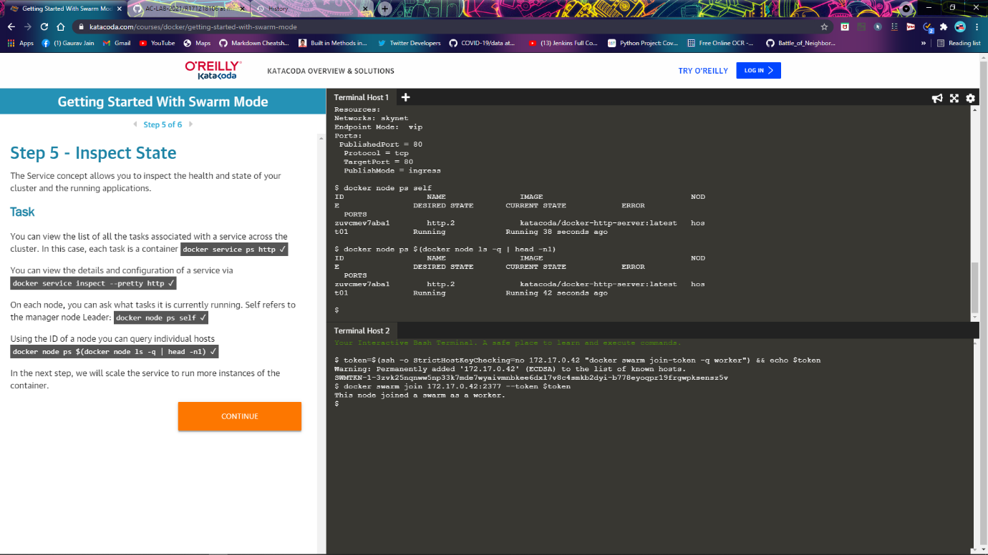

1. **Scale Service**

